**( الرَّحِيمِ الرَّحْمَٰنِ اللَّهِ بِسْمِ )**

**MOBILE COMPTUING**

**Name : Umer Khan**

**Std Id : BSEF18A020**

**Mobile computing:**



**Mobile computing** is [human–computer interaction](https://en.wikipedia.org/wiki/Human%E2%80%93computer_interaction) in which a [computer](https://en.wikipedia.org/wiki/Computer) is expected to be transported during normal usage, which allows for the transmission of data, voice, and video. Mobile computing involves mobile communication, mobile hardware, and mobile software. Communication issues include [ad hoc networks](https://en.wikipedia.org/wiki/Mobile_ad_hoc_network) and infrastructure networks as well as communication properties, [protocols](https://en.wikipedia.org/wiki/Communications_protocol), data formats, and concrete technologies. Hardware includes [mobile devices](https://en.wikipedia.org/wiki/Mobile_device) or device components. Mobile software deals with the characteristics and requirements of mobile applications.

**Git Hub:**



**GitHub, Inc.** is a provider of [Internet hosting](https://en.wikipedia.org/wiki/Internet_hosting_service) for [software development](https://en.wikipedia.org/wiki/Software_development) and [version control](https://en.wikipedia.org/wiki/Version_control) using [Git](https://en.wikipedia.org/wiki/Git" \o "Git). It offers the [distributed version control](https://en.wikipedia.org/wiki/Distributed_version_control) and [source code management](https://en.wikipedia.org/wiki/Source_code_management) (SCM) functionality of Git, plus its own features. It provides [access control](https://en.wikipedia.org/wiki/Access_control) and several collaboration features such as [bug tracking](https://en.wikipedia.org/wiki/Bug_tracking_system), [feature](https://en.wikipedia.org/wiki/Software_feature) requests, [task management](https://en.wikipedia.org/wiki/Task_management), [continuous integration](https://en.wikipedia.org/wiki/Continuous_integration) and [wikis](https://en.wikipedia.org/wiki/Wiki) for every project

Git Hub account **: umerk10**

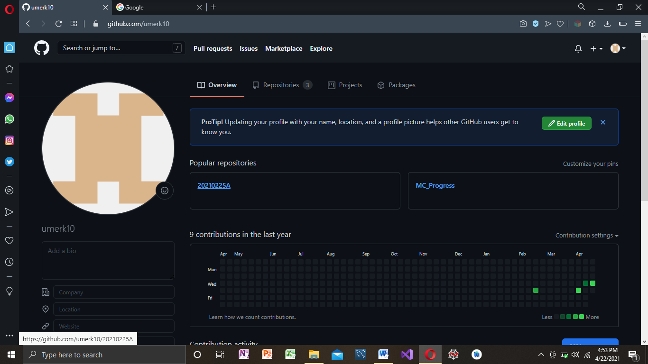

Repsitory Making : https://github.com/umerk10/20210225A.git

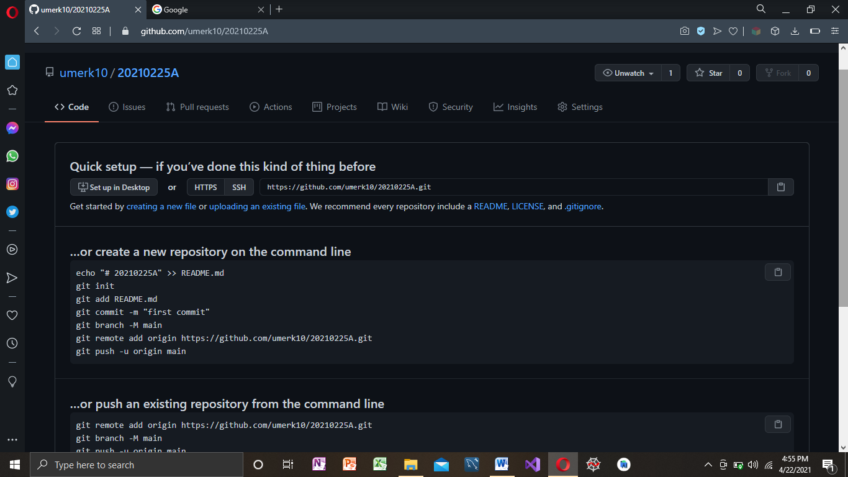

Git clone

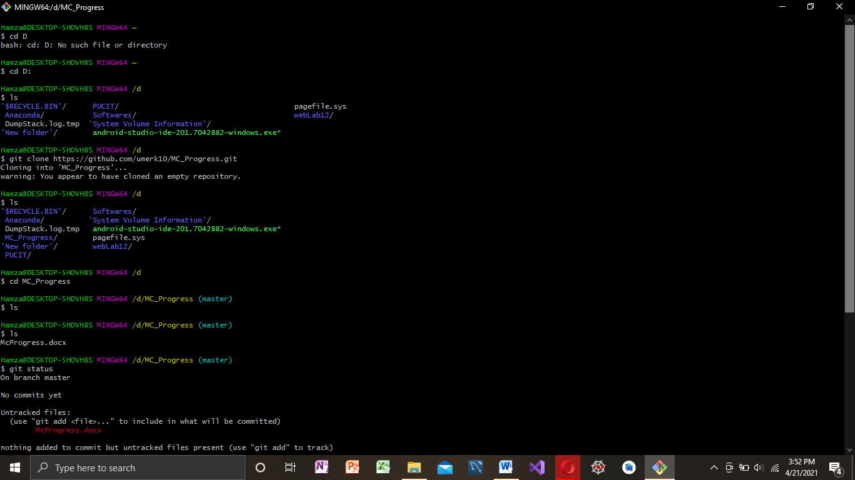

Git Add,Commit,Push,Status:

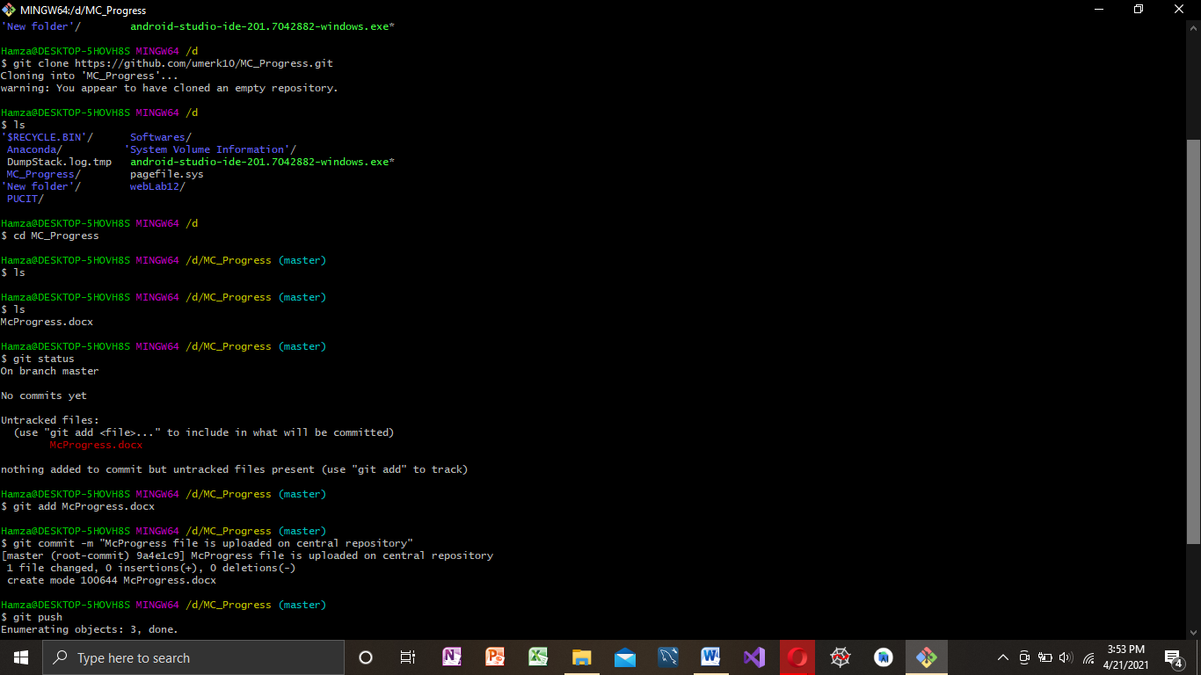

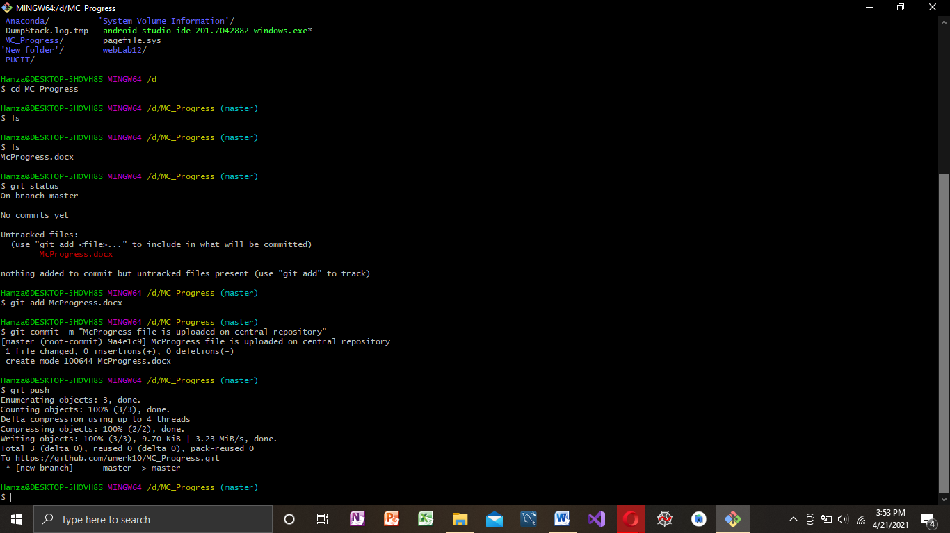

**Andriod Studio:**



**Android Studio** is the official[[7]](https://en.wikipedia.org/wiki/Android_Studio#cite_note-:0-7) [integrated development environment](https://en.wikipedia.org/wiki/Integrated_development_environment) (IDE) for [Google](https://en.wikipedia.org/wiki/Google)'s [Android](https://en.wikipedia.org/wiki/Android_(operating_system)) [operating system](https://en.wikipedia.org/wiki/Operating_system), built on [JetBrains](https://en.wikipedia.org/wiki/JetBrains" \o "JetBrains)' [IntelliJ IDEA](https://en.wikipedia.org/wiki/IntelliJ_IDEA" \o "IntelliJ IDEA) software and designed specifically for [Android development](https://en.wikipedia.org/wiki/Android_software_development).[[8]](https://en.wikipedia.org/wiki/Android_Studio#cite_note-8) It is available for download on [Windows](https://en.wikipedia.org/wiki/Windows), [macOS](https://en.wikipedia.org/wiki/MacOS" \o "MacOS) and [Linux](https://en.wikipedia.org/wiki/Linux) based operating systems or as a subscription-based service in 2020.[[9]](https://en.wikipedia.org/wiki/Android_Studio#cite_note-9)[[10]](https://en.wikipedia.org/wiki/Android_Studio#cite_note-10) It is a replacement for the [Eclipse Android Development Tools](https://en.wikipedia.org/wiki/Eclipse_(software)#Android_Development_Tools) (E-ADT) as the primary IDE for native Android application development.

Button:

A button consists of text or an icon (or both text and an icon) that communicates what action occurs when the user touches it.

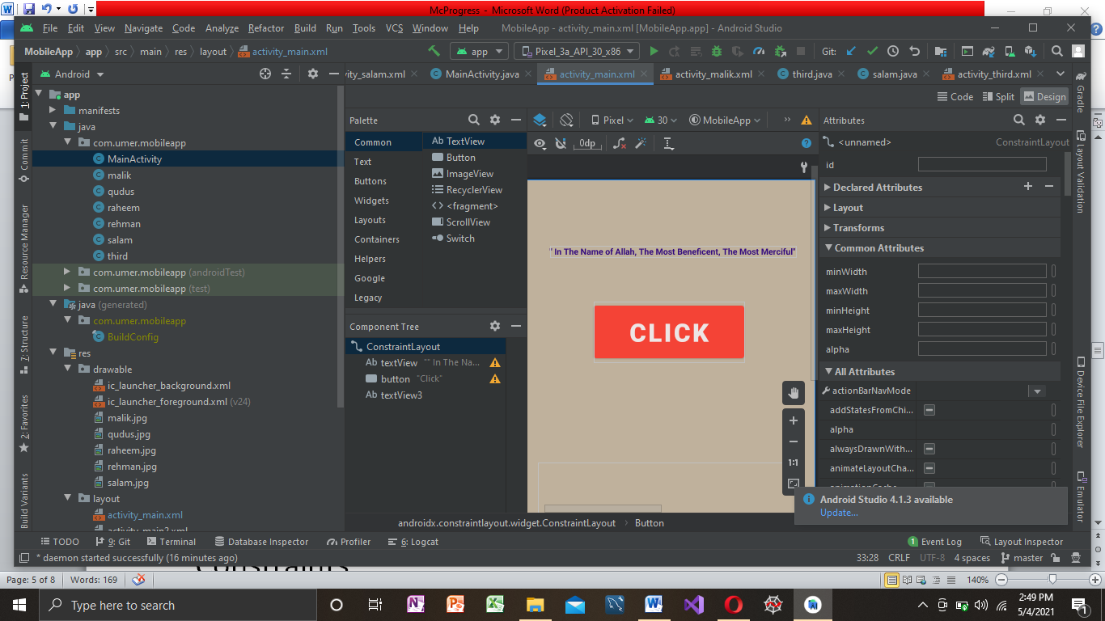

Constraints:

 A **constraint** represents a connection or alignment to another view, the parent layout, or an invisible guideline.

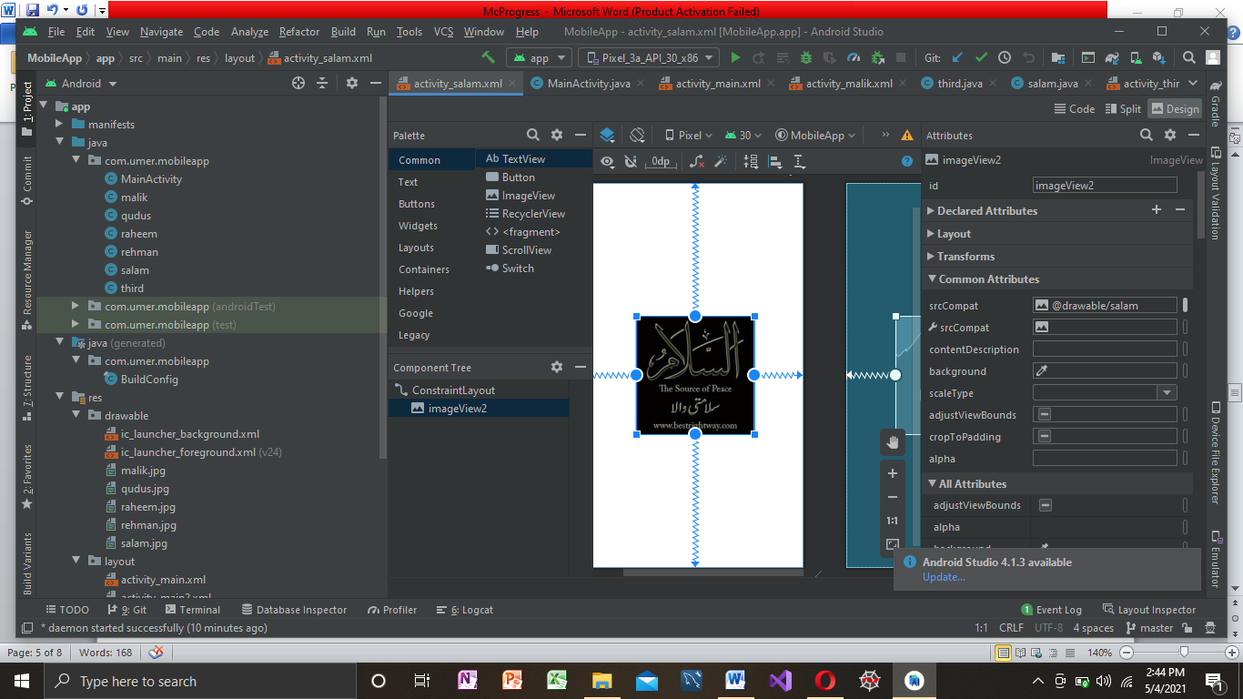

onClick Function:

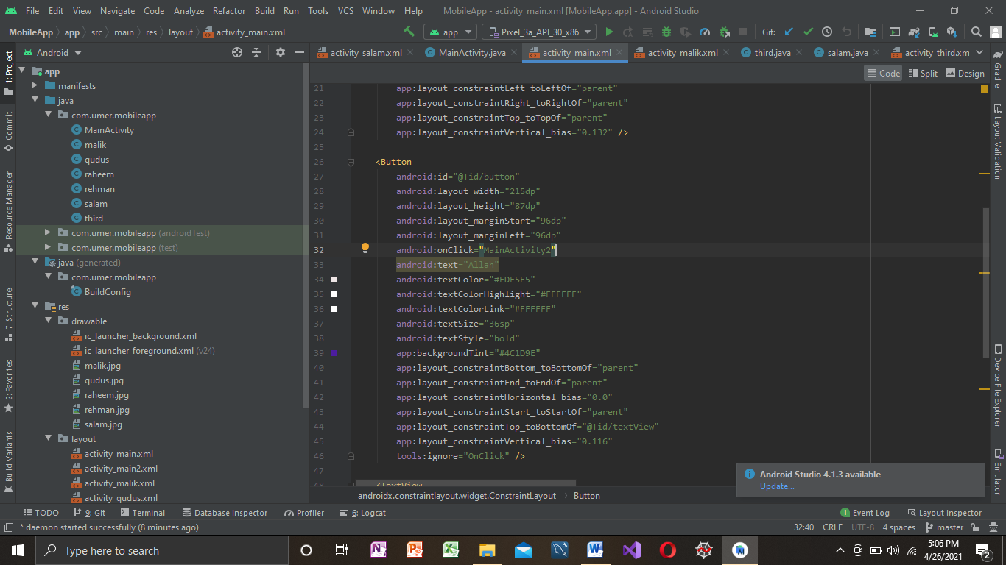

Intent:

**Android Intent** is the message that is passed between components such as activities, content providers, broadcast receivers, services etc. It is generally used with startActivity() method to invoke activity, broadcast receivers etc.

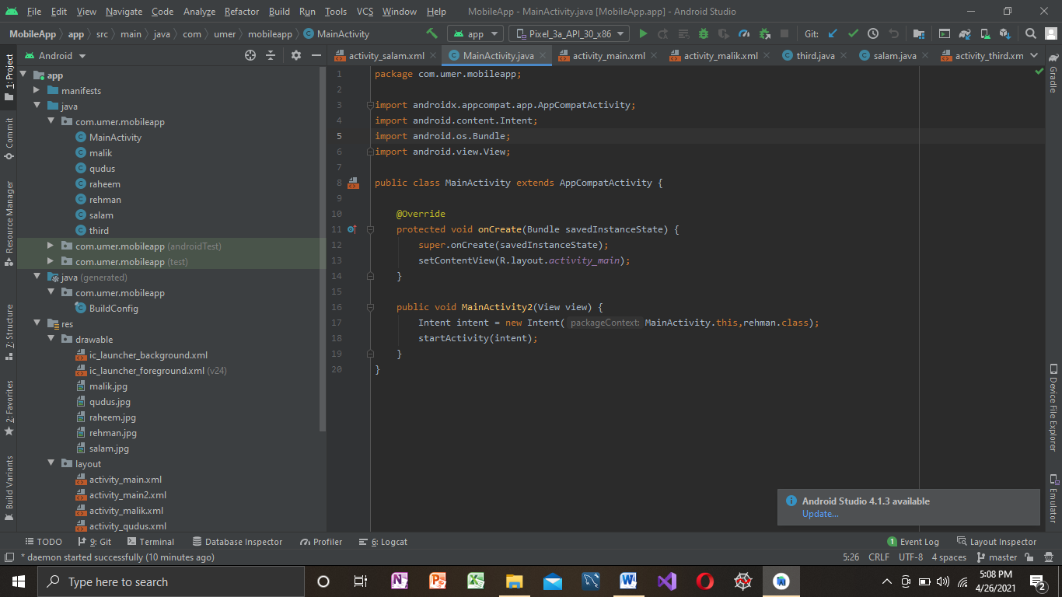

Animation:

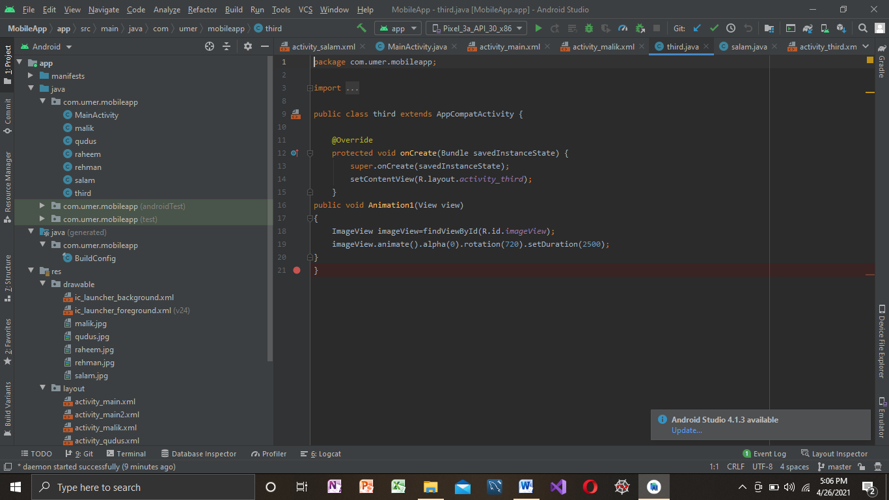

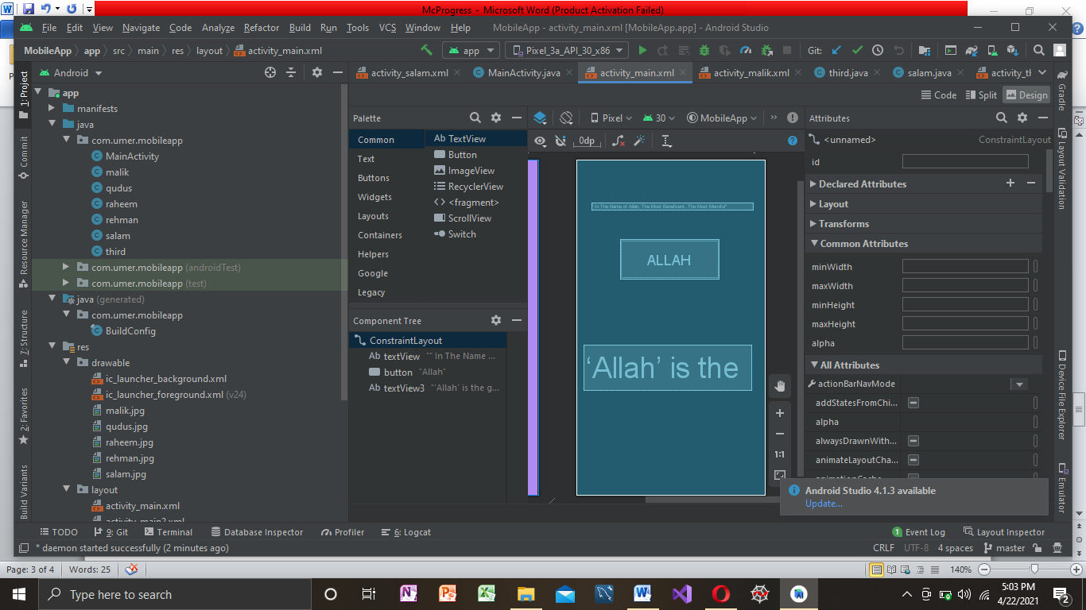

Basic Mobile Application:

 Video of basic app

Adapter:

Adapter is a bridge between UI component and data source that helps us to fill data in UI component. It holds the data and sends the data to an Adapter view then view can takes the data from the [adapter](https://abhiandroid.com/ui/adapter/) view and shows the data on different views like as list view

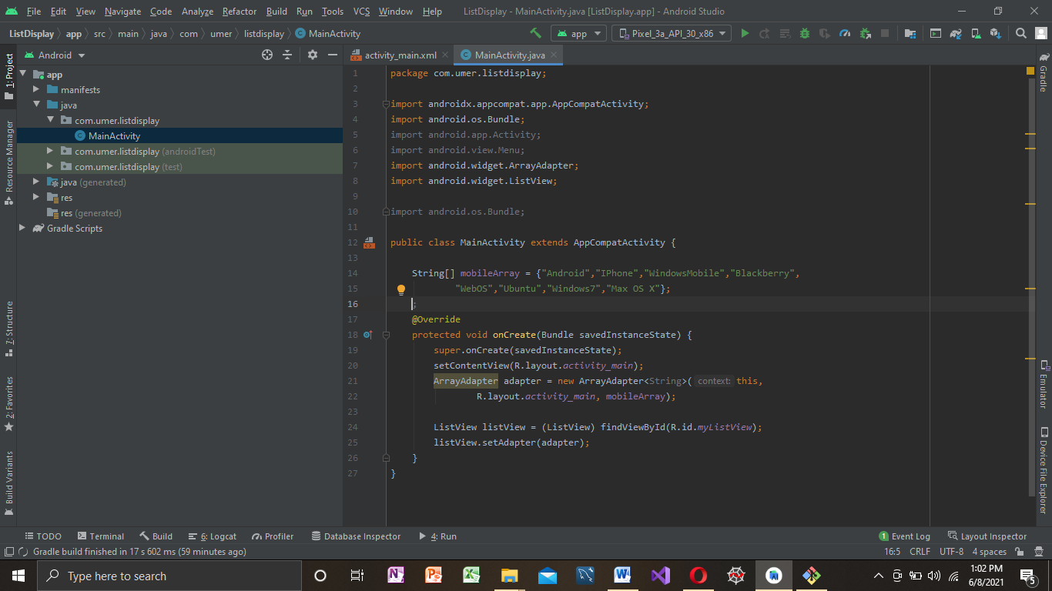

List View:

Android **ListView** is a view which groups several items and display them in vertical scrollable list. The list items are automatically inserted to the list using an **Adapter** that pulls content from a source such as an array or database. 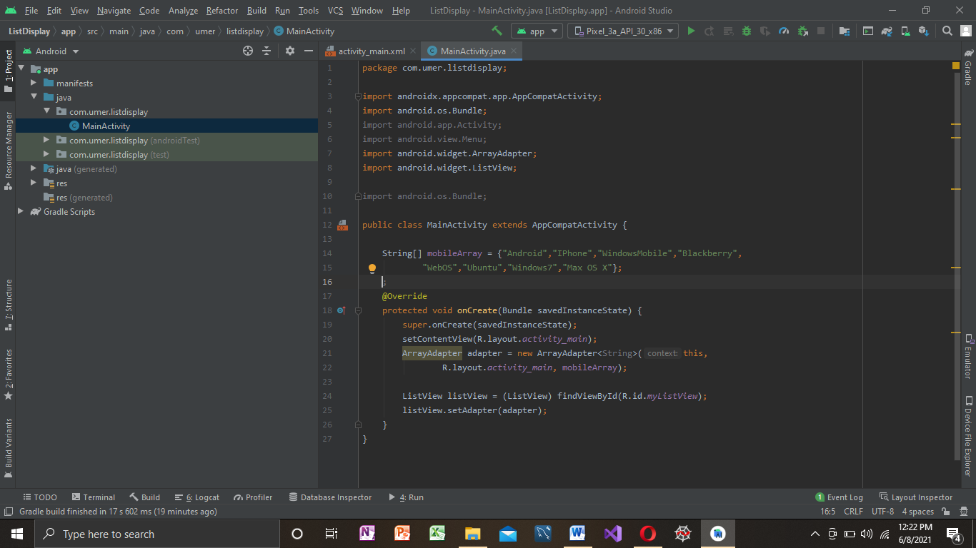

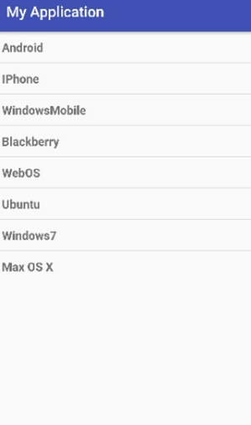

Drawer Navigation:

The **navigation drawer** is a UI panel that shows your app's main **navigation** menu. The **drawer** appears when the user touches the **drawer** icon in the app bar or when the user swipes a finger from the left edge of the screen.